**Setting up Application Environment**

Docker CLI installation

|  |  |
| --- | --- |
| Date | 1 November 2022 |
| Team Id | PNT2022TMID11590 |
| Project Name | Containment Zone Alert Application |

**Step 1.** Download Docker from docker.com and install it by running the Docker Desktop Installer.exe file.

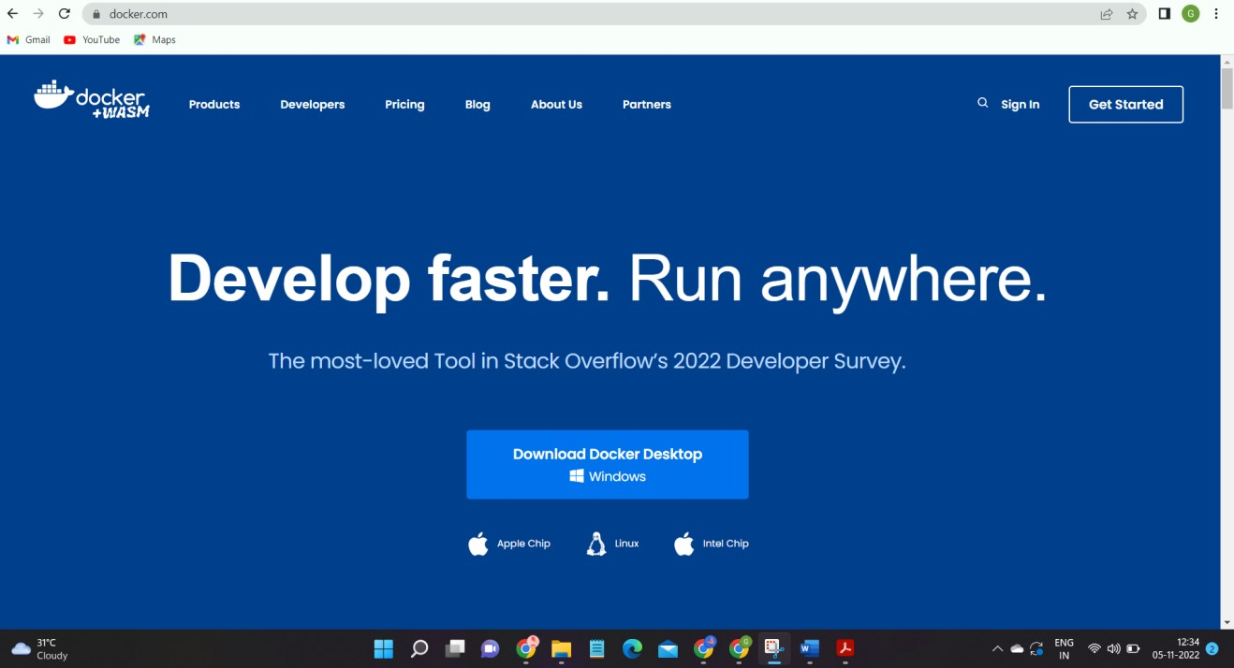

**Step 2**. Goto hub.docker.com register and create an account and login with the same

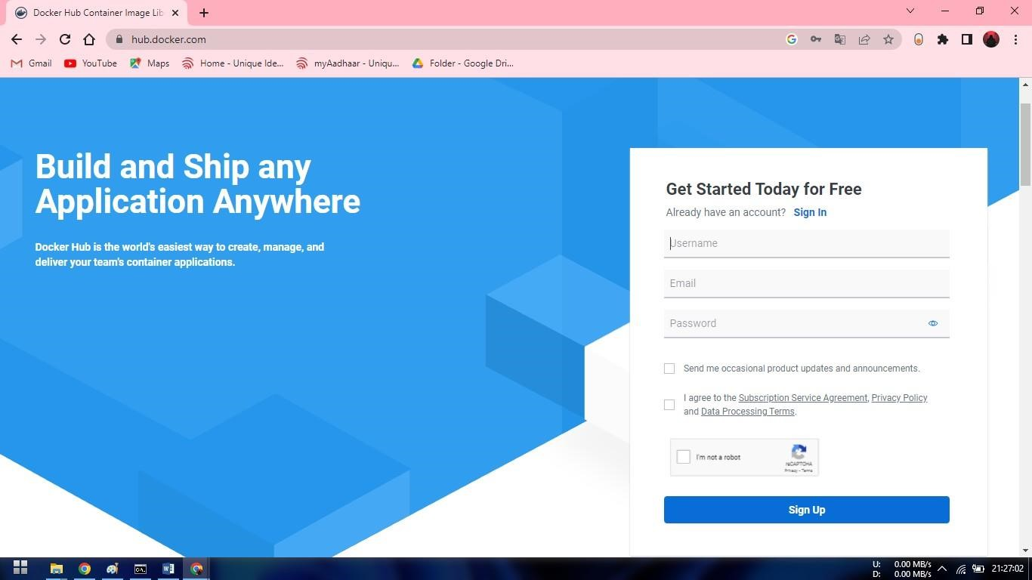

Step 3. Open Docker Desktop and start creating containers and images

